

**Micro-Credit Defaulter Model**

Submitted by:

**Shashank Chauhan**

**ACKNOWLEDGMENT**

Research papers that helped me in this project was as follows:

* <https://www.researchgate.net/publication/336800562_Credit_Card_Fraud_Detection_using_Machine_Learning_and_Data_Science>
* <https://www.academia.edu/44389277/Microfinance_in_Bangladesh_A_Case_Study_on_Islamic_Microfinance>

Articles that helped me in this project was as follows:

* <https://www.geeksforgeeks.org/ml-handling-imbalanced-data-with-smote-and-near-miss-algorithm-in-python/>

https://medium.com/kitepython/handling-imbalanced-datasets-with-smote-in-python-a94090d031f0

**INTRODUCTION**

* **Business Problem Framing**

This project was highly motivated project as it includes the real time problem for Microfinance Institution (MFI), and to the poor families in remote areas with low income, MFI to provide micro-credit on mobile balances to be paid back in 5 days. The Consumer is believed to be defaulter if he deviates from the path of paying back the loaned amount within the time duration of 5 days. For the loan amount of 5 (in Indonesian Rupiah), payback amount should be 6 (in Indonesian Rupiah), while, for the loan amount of 10 (in Indonesian Rupiah), the payback amount should be 12 (in Indonesian Rupiah).

* **Conceptual Background of the Domain Problem**

Generally, Credit Scores plays a vital role for loan approvals, and is very important in today’s financial analysis for an individual, Most of the loan lending vendors rely heavily on it, so in our case users has 5 days’ time to pay back the loan or else they are listed as defaulters which will impact the loan the credit score heavily, so there are few thing to lookout in this dataset as users who are taking extensive loans, user who have most frequent recharges in their main account have a good chance of 100% payback rate, and user who never recharged their main account for them loan should have never been approved as there is high chance for single user or default user taking multiple connections in name or documents of the family members.

* **Review of Literature**

The project objective is to find out the defaulters (i.e. the users who don’t repay the loan within 5 days). Now, Using Different Mathematical and statistical tools

Many assumptions regarding the data is made and data Cleaning is done.

After the Data Cleaning part Model Training takes place in which different models like: KNN, Random Forest Classifier, Decision Tree Classifier Ada Boost Classifier, Gradient Boosting Classifier etc. models are used for the Training of the data.

After Training of the data Hyper-parameter tuning is done and then the best model is designed.

* **Motivation for the Problem Undertaken**

This project was highly motivated project as it includes the real time problem for Microfinance Institution (MFI), and to the poor families in remote areas with low income, and it is related to financial sectors, as I believe that with growing technologies and Idea can make a difference, there are so much in the financial market to explore and analyse and with Data Science the financial world becomes more interesting.

**Analytical Problem Framing**

* **Mathematical/ Analytical Modeling of the Problem**
* This problem is a classification problem, the target variable is itself a statistical parameter. We have to predict in terms of a probability for each loan transaction, whether the customer will be paying back the loaned amount within 5 days of insurance of loan. In this case, Label ‘1’ indicates that the loan has been payed i.e. Non- defaulter, while, Label ‘0’ indicates that the loan has not been payed .for a loan amount of 5 payback amount should be 6,and for loan amount of 10 payback amount is 12.

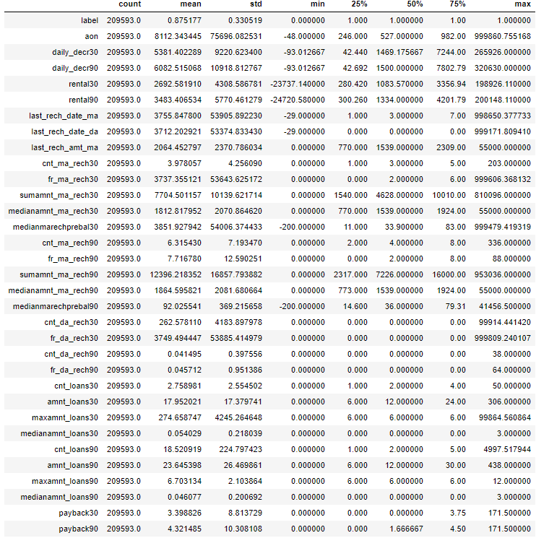

* From the above statistical summary of the above part of the dataset, **the important thing is that Some features even have negative values like the age on cellular network, main account last recharge date, data account last recharge date. Negative The Dataset we are having, consists of some features giving information about the user for the time span of 30 days and 90 days. According to me if we have data of large number of days for a particular user then we could interpret User's behaviour more precisely because many users have the tendency of repeating the same things. Thus the features having the data with a time span of 90 days gives more information about the user as compared to the features with a time span of 30 days.**
* **All the categories that is being made to make the visualizations easy are solemnly based on the Description i.e. statistical summary of the data plotted above *for instance* low comes under (0-25%), average comes under(25-75%) and high comes over 75% of the data values in a given feature.**
* Using MS EXCEL I have found the maximum values a feature can have, beyond these values the values are unimaginable.

***\*\*(for an example beyond the value [2500], the very next value in "aon" feature comes out to be around 2379 years, which means a user is using the telephone services from 359 BCE which is clearly not possible).\*\****

* I checked the correlation of the independent and dependent features and f**rom the correlation table it is also clear that the features with time span of 30 and 90 days almost have the same correlation thus we can drop one for the same information.**
* **Data Sources and their formats**
* **label :** Flag indicating whether the user paid back the credit amount within 5 days of issuing the loan{1:success, 0:failure}
* **msisdn :** mobile number of user
* **aon :** age on cellular network in days
* **daily_decr30:** Daily amount spent from main account, averaged over last 30 days (in Indonesian Rupiah)
* **daily_decr90:** Daily amount spent from main account, averaged over last 90 days (in Indonesian Rupiah)
* **rental30:** Average main account balance over last 30 days
* **rental90:** Average main account balance over last 90 days
* **last_rech_date_ma:** Number of days till last recharge of main account
* **last_rech_date_da:** Number of days till last recharge of data account
* **last_rech_amt_ma:** Amount of last recharge of main account (in Indonesian Rupiah)
* **cnt_ma_rech30:** Number of times main account got recharged in last 30 days
* **fr_ma_rech30:** Frequency of main account recharged in last 30 days
* **sumamnt_ma_rech30:** Total amount of recharge in main account over last 30 days (in Indonesian Rupiah)
* **medianamnt_ma_rech30:** Median of amount of recharges done in main account over last 30 days at user level (in Indonesian Rupiah)
* **medianmarechprebal30:** Median of main account balance just before recharge in last 30 days at user level (in Indonesian Rupiah)
* **cnt_ma_rech90:** Number of times main account got recharged in last 90 days
* **fr_ma_rech90:** Frequency of main account recharged in last 90 days
* **sumamnt_ma_rech90 :** Total amount of recharge in main account over last 90 days (in Indian Rupee) **medianamnt_ma_rech90:** Median of amount of recharges done in main account over last 90 days at user level (in Indian Rupee)
* **medianmarechprebal90:** Median of main account balance just before recharge in last 90 days at user level (in Indian Rupee)
* **cnt_da_rech30:** Number of times data account got recharged in last 30 days
* **fr_da_rech30:** Frequency of data account recharged in last 30 days
* **cnt_da_rech90:** Number of times data account got recharged in last 90 days
* **fr_da_rech90:** Frequency of data account recharged in last 90 days
* **cnt_loans30:** Number of loans taken by user in last 30 days
* **amnt_loans30:** Total amount of loans taken by user in last 30 days
* **maxamnt_loans30:** maximum amount of loan taken by the user in last 30 days
* **medianamnt_loans30:** Median of amounts of loan taken by the user in last 30 days
* **cnt_loans90:** Number of loans taken by user in last 90 days
* **amnt_loans90:** Total amount of loans taken by user in last 90 days
* **maxamnt_loans90:** maximum amount of loan taken by the user in last 90 days
* **medianamnt_loans90:** Median of amounts of loan taken by the user in last 90 days
* **payback30:** Average payback time in days over last 30 days
* **payback90:** Average payback time in days over last 90 days
* **pcircle:** telecom circle
* **pdate:** date

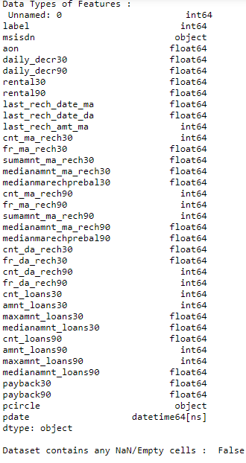

* **Data Pre-processing Done**
  + I checked the correlation of the independent and dependent features and f**rom the correlation table it is also clear that the features with time span of 30 and 90 days almost have the same correlation thus we can drop one for the same information.**
  + There were data for 30 and 90 days, so considering data for 90 days is adding more information rather than then data of 30 days.
  + Some features can’t have any negative value, so those features were treated accordingly.
  + Outliers are treated manually for the features giving some important information, and then the threshold values were set to make the data free from outliers.
  + Data lost is very less i.e **5.9%** which is less than the 7% which was stated in the documentation.
  + Applied SMOTETomek, to balance the dataset as the dataset was imbalanced dataset.
  + Applied StandardScaler to our dependent features.
  + Applied various machine learning model and compared it.
  + Applied hyper tuning several models, but couldn’t achieve much better results.
  + Saving final predictions in file.csv format.
* **Data Inputs- Logic- Output Relationships**

## **i) Average main account balance over last 90 days vs Loan Repayment Percentage within 5 days**

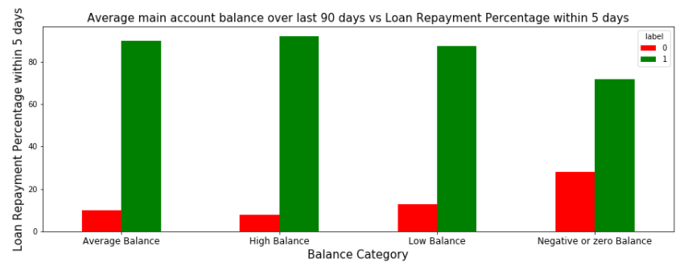

**From the above Graph and the crosstab table it is clear that:**

1) 28% of Users having negative or zero balance are defaulters, which is very high.  
2) 10% to 12% Users are defaulters which falls in the category of Average and Low balance category.  
3) Users having high balance and are defaulters are very less in number

**ii) Number of loans taken by user in last 90 days vs Loan Repayment Percentage within 5 days**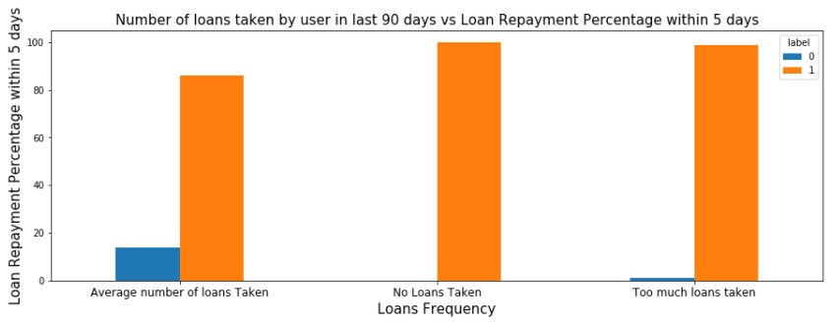

**From the above graph it is clear that:**

1) Users who take more number of loans are non-defaulters (i.e. 98% of the category) as they repays the loan within the given time i.e. 5 days.  
2) 14% of the Users are are among the average number of loan taken category are defaulters.

## **iii) Total amount of recharge in main account over last 90 days (in Indian Rupee) vs Loan Repayment Percentage within 5 days**

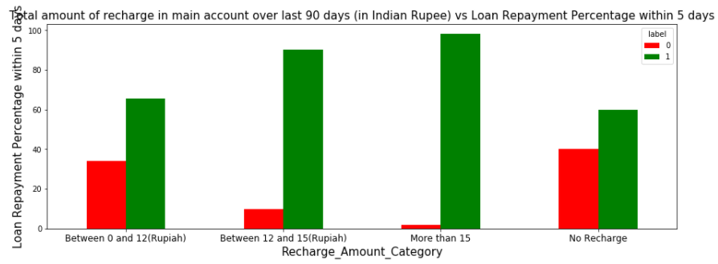

**From the above graph it is clear that:**

## 1) 40 % of the Users who do not even recharged in the 90 days are defaulters only. 2) Users who do very high amount of recharge always pays their loans on time. i.e. 98% of them are non-defaulters. 3) 34% of the Users who do less amount of recharge are defaulters. **iv) Average payback time in days over last 90 days vs Loan Repayment Percentage within 5 days**

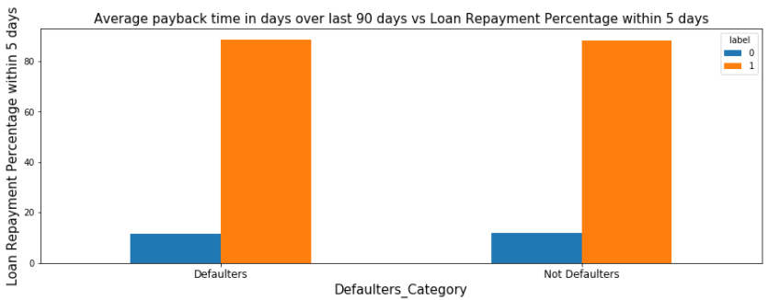

## **V) Total amount of loans taken by user in last 90 days vs Loan Repayment Percentage within 5 days**

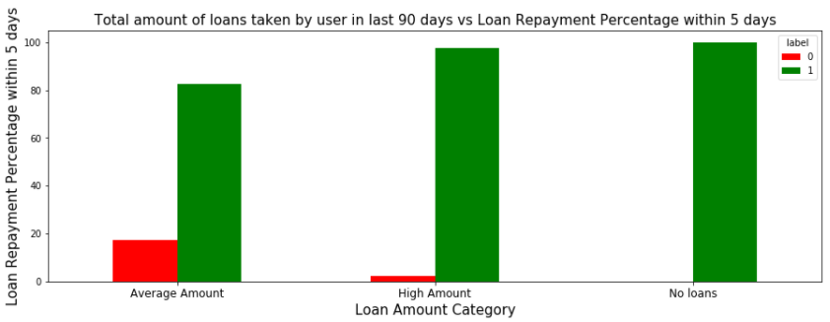

**From the above graph it is clear that:**

1) Users who did not take any loans are non-defaulters.  
2) Most of the Users (i.e. 97%) who take large amount of loans comes under non defaulter category.  
3) 17% of the users who take small loans are defaulters.

## **Vi) Number of times main account got recharged in last 90 days vs Loan Repayment Percentage within 5 days**

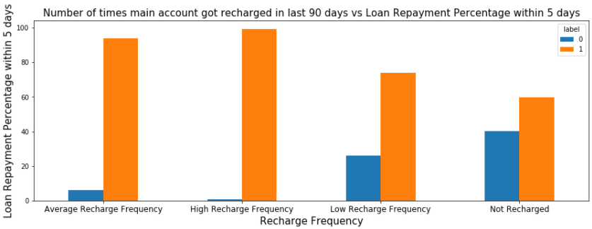

**From the above graph it is clear that:**

1) Among the Users who have not done a single recharge in 3 months 40% are defaulters.  
2) Among the Users who are very frequent in recharging and who always pay their loans on time are more in number i.e. 99% of the total category, which is a good news for the company.

## **Vii) Age on cellular network in days vs Loan Repayment Percentage within 5 days**

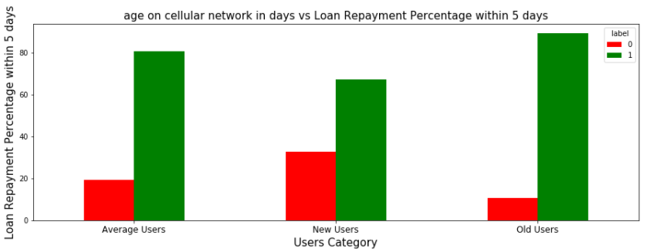

**From the above graph it is clear that:**

1) 32% of the users who are defaulters are the new users.  
2) Old Users are trusted and they are mostly non defaulters.

* **State the set of assumptions (if any) related to the problem under consideration**
* From the above statistical summary of the above part of the dataset, **the important thing is that Some features even have negative values like the age on cellular network, main account last recharge date, data account last recharge date. Negative values in these features make no sense thus these values should be removed.**
* **The Dataset we are having, consists of some features giving information about the user for the time span of 30 days and 90 days. According to me if we have data of large number of days for a particular user then we could interpret User's behaviour more precisely because many users have the tendency of repeating the same things. Thus the features having the data with a time span of 90 days gives more information about the user as compared to the features with a time span of 30 days.**
* **All the categories that is being made to make the visualizations easy are solemnly based on the Description i.e. statistical summary of the data plotted above *for instance* low comes under (0-25%), average comes under (25-75%) and high comes over 75% of the data values in a given feature.** Using MS EXCEL I have found the maximum values a feature can have, beyond these values the values are unimaginable.
* ***\*\*(for an example beyond the value [2500], the very next value in "aon" feature comes out to be around 2379 years, which means a user is using the telephone services from 359 BCE which is clearly not possible).\*\****
* I checked the correlation of the independent and dependent features and f**rom the correlation table it is also clear that the features with time span of 30 and 90 days almost have the same correlation thus we can drop one for the same information.**

* **Hardware and Software Requirements and Tools Used**
  + Hardware: 8GB RAM, 64-bit, 9th gen i7 processor.
  + Software: MS-Excel, Jupyter Notebook, python 3.6.

**Libraries used:-**

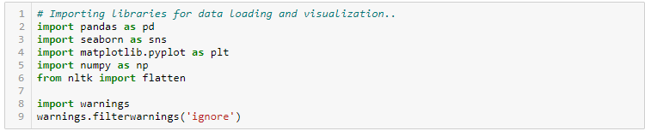

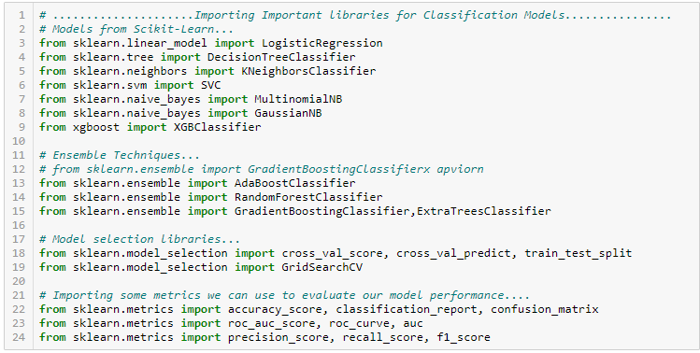

**CONCLUSION**

* **Key Findings and Conclusions of the Study**

1) 28% of Users having negative or zero balance are defaulters, which is very high.

2) 10% to 12% Users are defaulters which falls in the category of Average and Low balance category.  
3) Users having high balance and are defaulters are very less in number.  
4) Users who take more number of loans are non-defaulters (i.e 98% of the category) as they repays the loan within the given time i.e. 5 days.  
5) 14% of the Users are among the average number of loan taken category are defaulters.  
6) 40 % of the Users who do not even recharged in the 90 days are defaulters only.  
7) Users who do very high amount of recharge always pays their loans on time. i.e 98% of them are non-defaulters.  
8) 34% of the Users who do less amount of recharge are defaulters.  
9) Users who did not take any loans are non-defaulters.  
10) Most of the Users (i.e. 97%) who take large amount of loans comes under non defaulter category.  
11) 17% of the users who take small loans are defaulters.  
12) Among the Users who have not done a single recharge in 3 months 40% are defaulters.  
13) Among the Users who are very frequent in recharging and who always pay their loans on time are more in number i.e. 99% of the total category, which is a good news for the company.q  
14) 32% of the users who are defaulters are the new users.  
15) Old Users are trusted and they are mostly non defaulters.

16) Random Forest Classifier performed the best AUC_ROC_SCORE **i.e. 94.7%.**

* **Learning Outcomes of the Study in respect of Data Science**
* Visualizations and Data Cleaning part was very crucial as without the cleaning we were not able to judge the data effectively and won’t be able to remove the outliers thus adding in to the errors.
* Visualizations helped a lot in finding out those outliers values and helped in finding out the features having direct relation between the feature and the label.
* We could have experimented by using PCA for dimension reducing and could have tried opting some other technique instead of SMOTETomek.
* **Limitations of this work and Scope for Future Work**
* Machine Learning Algorithms like KNN took enormous amount of time to build the model.
* I could have experimented by using PCA and could have tried opting some other technique instead of SMOTETomek.
* Some altering notification before the deadlines can play a major role, in reducing the defaulter rate, whether it is sms notification or intimation using a call.
* I suggest to combine both the account i.e. data and main account and provide both services on each recharge to increase the profit.